

Assessment Cover Page
Student Full Name | Maciel Lourdes Cáceres Orozco
Student Number | 2026540
Module Title | Statistical Techniques for Data Analysis
Assessment Title | Stats- HDip DBA Sept-26 CA-1 40%
Lecturer/Supervisor | Taufique Ahmed
Assessment Due Date | 1/11/2026
Date of Submission | 1/11/2026
GitHub Repository | https://github.com/2026540-MacielCaceres/CA1_Report_Student_Performance.git
Use of AI Tools
I used one generative AI tool, Claude (Anthropic) during October 2026. Claude was used to shortlist candidate datasets, draft Python code for the descriptive statistics, plots, Binomial, Poisson and normality analyses, assemble that code into Jupyter notebooks, explain the statistical concepts, and draft supporting arguments for the discussion section. I selected the dataset, ran the code on my own copy of student-por.csv, checked the results of every graphic, and rewrote the AI-drafted text in my own words with my opinion about the analysis. The four competencies of the AI Fluency Framework are addressed below, and the exact prompts are in Appendix A (31 October 2026) and Appendix B (5th October 2026).

Contents
1. Introduction and dataset 4
2. Descriptive statistics 4
3. Discrete distributions 6
3.1 Binomial distribution 6
3.2 Poisson distribution 7
4. Normal distribution 8
5. Importance of the distributions and choice of variables 9
References 11
Appendix A: Use of AI 12
A.1 AI Declaration using the AI Fluency Framework 12
A.2 Prompts and outputs 13
Appendix B: Use of AI Screenshots 17

1. Introduction and dataset
To kick things off, this report dives into the Student Performance dataset (Cortez and Silva, 2008; Cortez, 2008), which describes secondary school students across two Portuguese institutions. Specifically, I focused on the Portuguese-language file, consisting of 649 students and 33 variables, with the great advantage of having zero missing values and no duplicate entries. The dataset offers a rich mix of categorical variables—such as school, sex, address, family size, and higher education aspirations—alongside key numerical variables like age, weekly study time, past academic failures, absences, and three periodic grades (G1, G2, and G3) measured on a 0–20 scale, where G3 represents the final grade.
When it comes to the technical implementation, all statistical computations and data processing were carried out in Python using standard data analytics libraries including pandas, NumPy, SciPy, Matplotlib, and seaborn (McKinney, 2010; Harris et al., 2020; Virtanen et al., 2020; Hunter, 2007; Waskom, 2021). The complete code and outputs are fully documented in the accompanying Jupyter notebook. Additionally, an AI assistant supported various phases of this work, and its contribution is formally declared in Appendix A (Anthropic, 2026).

2. Descriptive statistics
When breaking down the main numerical variables, relying solely on the mean and standard deviation wouldn't paint a complete picture. Because several distributions lack symmetry, I also report the median, skewness, and excess kurtosis to capture their true shape.
Variable | Mean | Median | SD | Skewness | Excess kurtosis
G1 | 11.40 | 11 | 2.75 | 0.00 | 0.04
G2 | 11.57 | 11 | 2.91 | -0.36 | 1.66
G3 | 11.91 | 12 | 3.23 | -0.91 | 2.71
absences | 3.66 | 2 | 4.64 | 2.02 | 5.78
failures | 0.22 | 0 | 0.59 | 3.09 | 9.82
Table 1. Descriptive statistics of the main numerical variables (n = 649).

Looking closely at the numbers, the final grade (G3) has a mean of 11.91 and a median of 12. However, its skewness sits at −0.91 with an excess kurtosis of 2.71, revealing a pronounced left tail. Investigating further, this is largely driven by a small group of 15 students (2.3% of the cohort) who obtained a G3 score of exactly zero. In stark contrast, the first-period grade (G1) is remarkably symmetric. Meanwhile, absences are heavily right-skewed (median of 2, maximum of 32), with 37.6% of students having zero absences. Academic failures show an even more extreme right skew, as 84.6% of students report no prior failures.
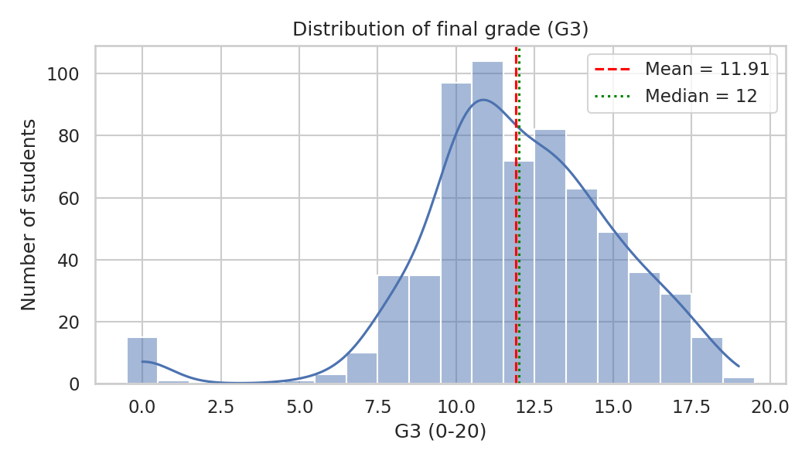
Plot 1. Histogram of G3 with density curve.
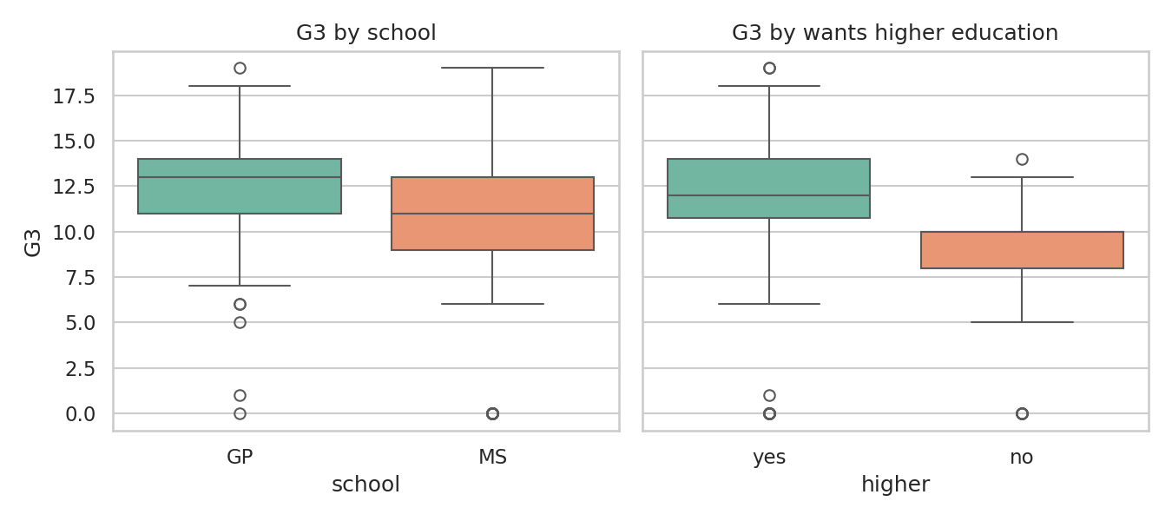
Plot 2. G3 by school and by wish to enter higher education.
To visualize this distribution, Plot 1 displays the histogram of G3 alongside its density curve. The distribution peaks nicely around 10–12, featuring a longer upper tail and an isolated spike at zero. Because the mean (11.91) sits so close to the median (12), it becomes evident that the negative skewness stems almost entirely from those zero grades. Turning to categorical comparisons via boxplots (Plot 2), we see clear structural differences: students at GP exhibit a higher median grade than those at MS (13 vs 11) alongside a tighter spread (SD of 2.63 vs 3.83). Furthermore, students who express no desire to pursue higher education score noticeably lower on average (mean of 8.80 vs 12.28).
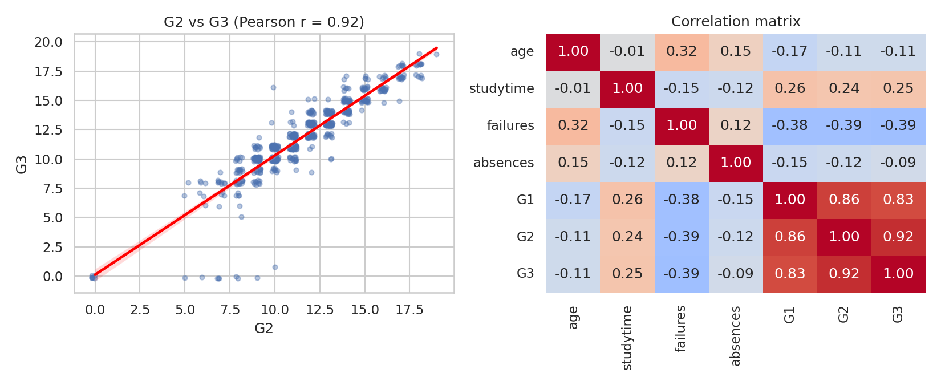
Plot 3. Scatter plot of G2 against G3 and correlation heatmap.
Examining the relationships between variables in Plot 3, G3 behaves almost as a linear function of G2 (r = 0.92) and G1 (r = 0.83). Consequently, prior academic achievement is by far the strongest predictor of final success. Past failures show a moderate negative correlation with G3 (r = −0.39), whereas absences (r = −0.09) and age (r = −0.11) exhibit very weak associations. Interestingly, the outlying points where G3 equals 0 while G2 ranges between 5 and 8 likely represent students who missed the final exam, although the dataset itself does not explicitly confirm this. Naturally, correlation does not imply causation. Moreover, a closer look at absences uncovers a data-quality quirk: 87.4% of non-zero absence values are even numbers, hinting at a potential recording artifact.

3. Discrete distributions

3.1 Binomial distribution
To model student success, I defined passing as achieving G3 ≥ 10. Within the dataset, 549 out of 649 students passed, yielding an estimated probability of success p̂ = 0.8459. For a random class of n = 20 students, the number of passes X can be suitably modeled as Binomial(20, 0.8459): the trial count is fixed, each trial results in one of two outcomes, and the success probability remains constant. While independence is technically approximate due to sampling without replacement, the sample size n is sufficiently small relative to the population. The probability mass function, mean, and variance are defined as:
P(X = k) = C(n, k) p^k (1 − p)^{n-k}, E[X] = np = 16.92, Var(X) = np(1 − p) = 2.61 (SD = 1.61).
For instance, the probability of exactly 17 students passing is P(X = 17) = C(20, 17) × 0.8459^17 × 0.1541^3 = 0.2425, while the probability of at least 18 students passing is P(X ≥ 18) = 0.385 (a 38.5% chance). To test the robustness of this model, I simulated 10,000 random classes of 20 students: the resulting simulated mean (16.89) and SD (1.59) match the theoretical values of 16.92 and 1.61 exceptionally well.
p_hat = df["passed"].mean() # 0.8459
X = stats.binom(20, p_hat)
print(X.mean(), X.var(), X.sf(17)) # E[X], Var, P(X >= 18)
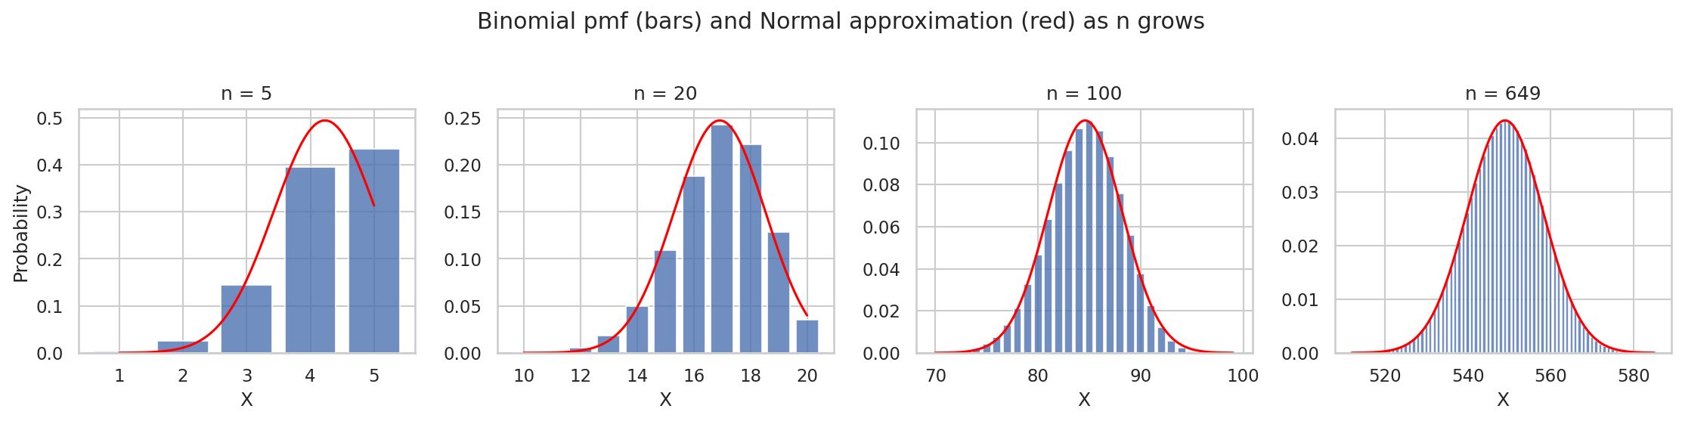
Plot 4. Binomial probabilities (bars) and Normal approximation (red) for n = 5, 20, 100 and 649.
Plot 4 illustrates how sample size influences the distribution. As n increases, the skewness (1 − 2p) / √(np(1 − p)) drops from −0.86 for n = 5 down to −0.43 (n = 20), −0.19 (n = 100), and −0.075 (n = 649), while the maximum error of the Normal approximation decreases from 0.064 to 0.005. The standard rule of thumb requiring np ≥ 5 and n(1 − p) ≥ 5 fails for n = 5 and n = 20 (where n(1 − p) is 0.8 and 3.1) but holds firmly for n = 100 and n = 649. This beautifully demonstrates the De Moivre–Laplace theorem: for large sample sizes, the Binomial distribution converges to a symmetric, bell-shaped curve.

3.2 Poisson distribution
Given that absences represent discrete counts, I initially tested a Poisson model, P(X = k) = e^−λ λ^k / k!, whose defining characteristic is equidispersion (meaning E[X] = Var(X) = λ). Estimating λ̂ = 3.66, I found that the sample variance is actually 21.54, resulting in a dispersion index of 5.89. The Poisson model predicts that only 2.6% of students have zero absences, whereas 37.6% are observed with none. Unsurprisingly, a chi-square goodness-of-fit test decisively rejects the model (χ² = 4958, p < 0.001; Plot 5). This confirms that absences suffer from severe overdispersion and zero-inflation, characterized by a large group of students with zero absences alongside a minority with frequent absences.
lam = df["absences"].mean(); var = df["absences"].var()
print(lam, var, var / lam) # 3.659 21.537 5.89
print(stats.poisson.pmf(0, lam)) # 0.026 (observed share: 0.376)
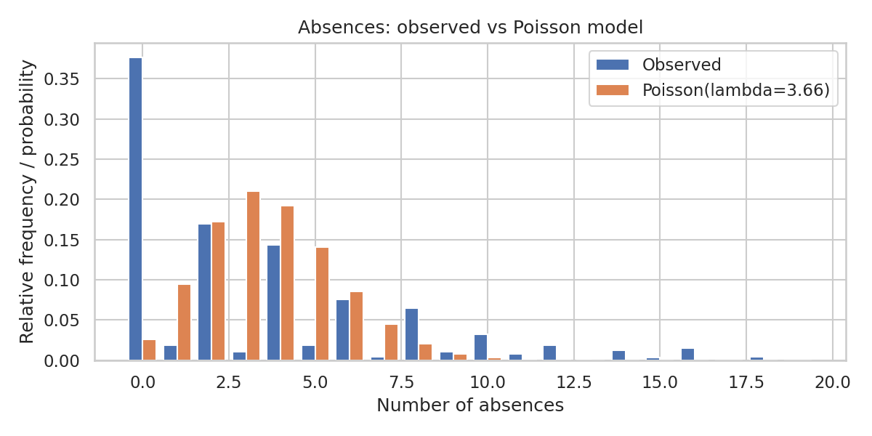
Plot 5. Observed absences against a Poisson(3.66) model.
On the other hand, the Poisson distribution excels at modeling genuinely rare events. For example, 15 students (2.3%) attained G3 = 0. For a typical class of 30, the number Y of such students should follow a Poisson distribution with parameter λ = 30 × 15/649 = 0.693. This yields P(Y = 0) = e^−0.693 = 0.500, indicating a 50% chance that a given class contains at least one student with a zero grade. Across 10,000 simulated classes, the mean was 0.704 and the variance 0.644 (compared to 0.693 theoretically), showing a strong alignment in frequencies (Plot 6; P(Y = 1) is 0.368 in simulation versus 0.347 under the Poisson model).
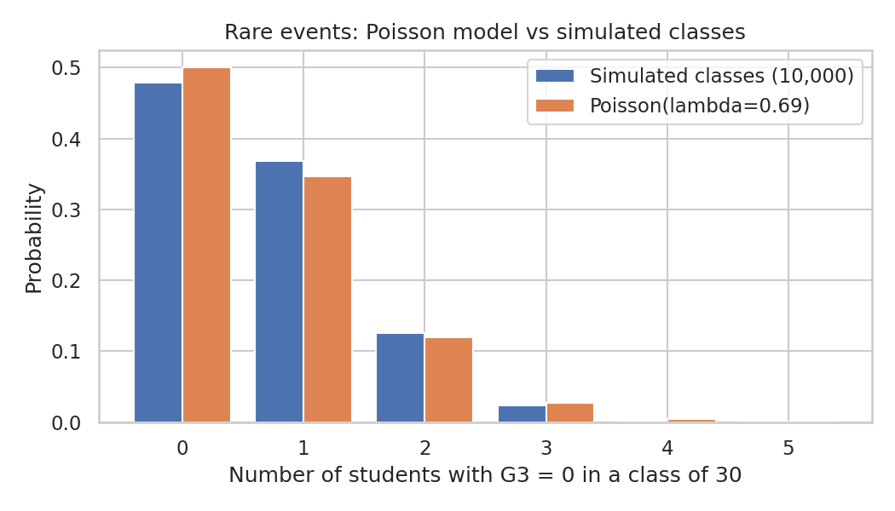
Plot 6. Number of zero-grade students in a class of 30: simulation against Poisson(0.693).
Two fundamental limits explain how sample size governs these distributions. First, as n grows while p = λ/n shrinks, the Binomial distribution converges to the Poisson, with the maximum probability difference dropping from 0.052 at n = 10 to 0.0008 at n = 500. Second, as λ increases, the Poisson distribution becomes symmetric—featuring a skewness of 1/√λ (ranging from 1.00 for λ = 1 down to 0.14 for λ = 50)—and closely approximates a Normal(λ, λ) distribution (Plot 7). 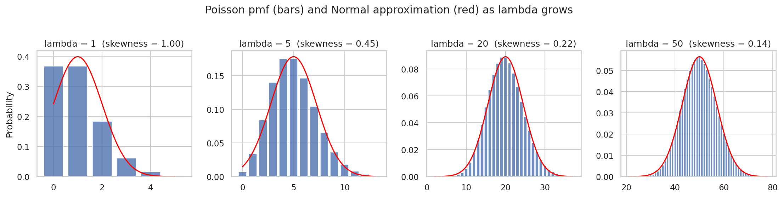
Plot 7. Poisson probabilities (bars) and Normal approximation (red) for λ = 1, 5, 20 and 50.

4. Normal distribution
Because G3 is measured on a 0–20 scale and can be treated as approximately continuous, I fitted a Normal distribution using the sample mean and standard deviation, N(μ = 11.91, σ² = 3.23²). Its density function is defined as f(x) = exp(−(x − μ)² / 2σ²) / (σ√2π), with standardized grades expressed as z = (x − μ)/σ. Plot 8 compares this fitted curve against the histogram and incorporates a Normal Q–Q plot.
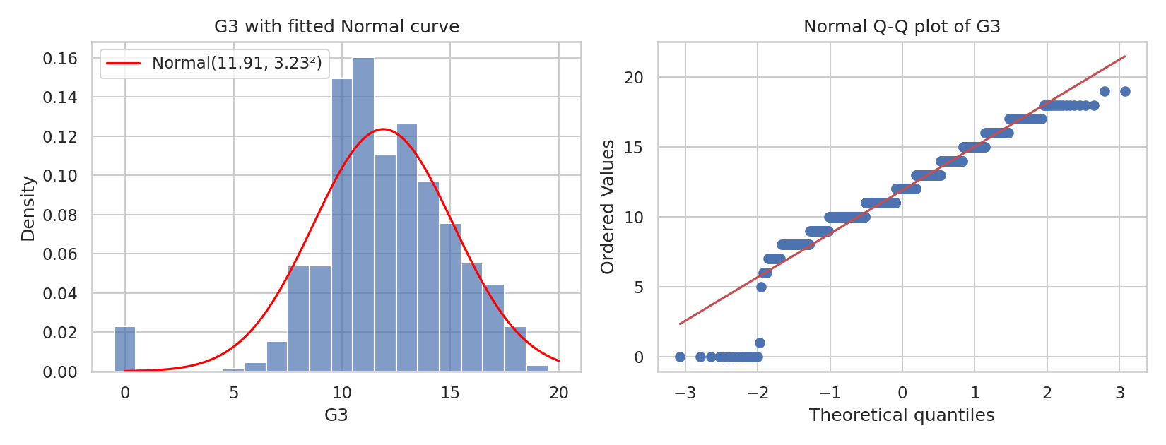
Plot 8. G3 with fitted Normal curve (left) and Normal Q–Q plot (right).
The fit is remarkably good in the center and upper tail, but struggles in the lower tail where the Q–Q plot points diverge due to the zero grades. Formal statistical tests reject strict normality (Shapiro–Wilk W = 0.926, p < 0.001; D’Agostino K² = 114.2, p < 0.001), though with n = 649, these tests are sensitive enough to detect even minor departures. Looking at the empirical rule, 77.3% of grades fall within one standard deviation of the mean (compared to 68.3% normally), 97.1% within two (95.5%), and 97.5% within three (99.7%).
Despite these deviations, the Normal model remains a practical tool for answering key questions. Applying a continuity correction, we find P(G3 ≥ 14) ≈ P(Z ≥ (13.5 − 11.91)/3.23) = P(Z ≥ 0.49) = 0.311, which aligns closely with the observed 0.299. The 90th percentile matches at 16.0 under both the model and the data. However, the model overstates failure rates: P(G3 ≤ 9) is estimated at 0.228 compared to 0.154 observed, because probability mass is incorrectly pulled into the lower tail by the zeros. When excluding the 15 zero-grade students entirely, skewness drops to 0.13 and excess kurtosis to −0.12, indicating that the remaining 634 grades are almost perfectly Normal. Thus, the departure from normality stems from a distinct, isolated subgroup rather than the wider student population.
mu, sigma = g3.mean(), g3.std()
print(stats.shapiro(g3)) # W = 0.926, p = 2.4e-17
print(stats.norm.sf(14 - 0.5, mu, sigma)) # P(G3 >= 14) = 0.311
print(g3[g3 > 0].skew(), g3[g3 > 0].kurt()) # 0.13 -0.12

5. Importance of the distributions and choice of variables
Each probability distribution serves a distinct analytical purpose. The Binomial model captures successes across a fixed number of trials, making it ideal for proportions like pass rates. The Poisson model handles event counts, particularly rare occurrences. Meanwhile, the Normal model represents continuous, roughly symmetric measurements and, via the Central Limit Theorem, governs sums and averages. I selected pass/fail status and G3 as the clearest outcome measures, and absences as the sole genuine count variable. The fact that the Poisson model fails for absences but successfully captures rare zero grades highlights an essential lesson: a statistical distribution must faithfully reflect the underlying mechanism generating the data.
Variable | Skewness | Excess kurtosis | KS distance to Normal
G1 | 0.00 | 0.04 | 0.086
G2 | -0.36 | 1.66 | 0.088
G3 | -0.91 | 2.71 | 0.124
absences | 2.02 | 5.78 | 0.215
log(1 + absences) | 0.18 | -1.25 | 0.246
Table 2. Shape of the main variables and Kolmogorov–Smirnov distance to a fitted Normal.
Table 2 compares the distributional shapes: G1 and G2 sit closest to Normal, G3 deviates slightly due to zero grades, and absences exhibit strong right-skewness. Could discrete variables be treated as Normal? For the Binomial distribution, yes when sample size is large—at n = 649 (np = 549, n(1 − p) = 100), the maximum error is a negligible 0.005, whereas at n = 20 it is 0.026. For absences, however, the answer is no. A Normal model fitted with sample mean and SD assigns an 18.5% probability to negative absences, completely ignoring the fact that 37.6% of students have exactly zero absences (Plot 9). Even transforming the variable via log(1 + absences) leaves a stubborn spike at zero. Similarly, a Poisson model with λ = 3.66 remains too skewed (0.52; max error 0.036) to justify a Normal approximation.
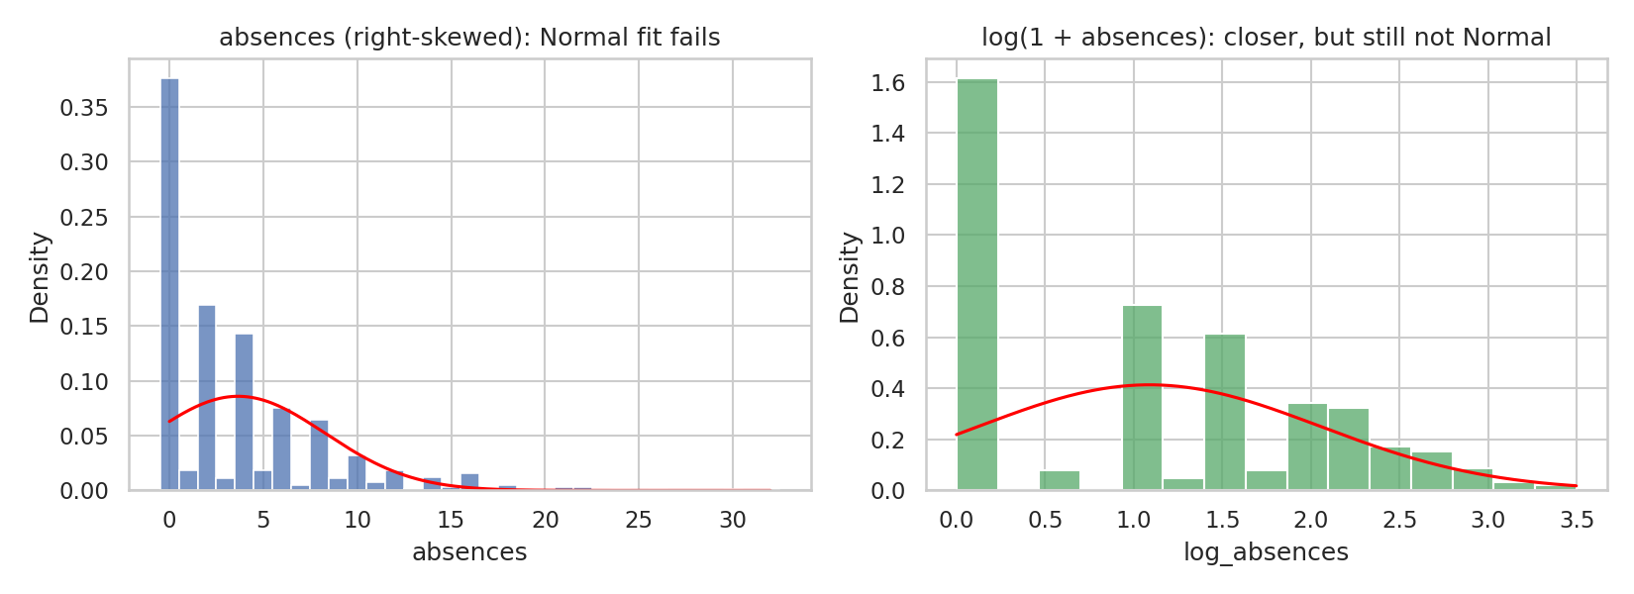
Plot 9. Absences (left) and log(1 + absences) (right) with fitted Normal curves.
To conclude, pass counts are effectively described by a Binomial distribution that transitions to Normal for large samples; rare zero grades align with a Poisson process; and final grades follow a Normal distribution except for the zero-grade anomaly. Conversely, absences require specialized zero-inflated models. Key limitations of this study include data originating from only two schools, the lack of an explicit explanation for G3 = 0 cases, and potential inaccuracies in absence recording.

References
Anthropic (2026) Claude Sonnet 5.5 [Software]. (Accessed: 6 October 2026). See appendix for prompt used and text generated.
Cortez, P. (2008) Student Performance [Dataset]. UCI Machine Learning Repository. Available at: https://archive.ics.uci.edu/dataset/320/student+performance (Accessed: 6 October 2026).
Cortez, P. and Silva, A. (2008) ‘Using data mining to predict secondary school student performance’, in Brito, A. and Teixeira, J. (eds.) Proceedings of 5th FUture BUsiness TEChnology Conference (FUBUTEC 2008). Porto, Portugal: EUROSIS, pp. 5–12.
Harris, C.R. et al. (2020) ‘Array programming with NumPy’, Nature, 585, pp. 357–362.
Hunter, J.D. (2007) ‘Matplotlib: a 2D graphics environment’, Computing in Science & Engineering, 9(3), pp. 90–95.
McKinney, W. (2010) ‘Data structures for statistical computing in Python’, in van der Walt, S. and Millman, J. (eds.) Proceedings of the 9th Python in Science Conference, pp. 56–61.
Virtanen, P. et al. (2020) ‘SciPy 1.0: fundamental algorithms for scientific computing in Python’, Nature Methods, 17, pp. 261–272.
Waskom, M.L. (2021) ‘seaborn: statistical data visualization’, Journal of Open Source Software, 6(60), p. 3021.

Appendix A: Use of AI

A.1 AI Declaration using the AI Fluency Framework
For use in assessment briefs and student submissions. Lecturers complete the Lecturer Expectations column per assessment; students complete the Student Response column.
AI competence | Reflective prompts (to students) | Lecturer expectations | Student response
Delegation  Deciding whether & when to use AI | Identify the specific tasks in this assessment where you chose to use AI, and explain your reasoning. Where did AI add value? Where did you decide not to use it, and why? | You may use AI to support your learning and development of the application. Clearly identify where you used AI and where you completed the work independently. | I used Claude (Anthropic) to shortlist candidate datasets, draft Python code for the descriptive statistics, plots, Binomial, Poisson and normality analyses, assemble the Jupyter notebook and a first draft of the report, explain the code and statistical concepts, and draft supporting arguments for the discussion (discrete vs continuous models, the Central Limit Theorem and limitations). I chose the Student Performance dataset and the variables analysed. I did not use AI to decide my final conclusions, which I based on the results of my own runs.
Description  How you prompted the AI | Include the exact prompts you used in your appendix (recorded on the AI Tools declaration). Reflect on how you communicated your goals to the AI — did you need to iterate or refine your prompts to get useful output? | You must provide the exact prompts and relevant AI outputs used during the development of your application. | My prompts (A.2) named the dataset, the variables, the libraries and the exact outputs required, and set constraints such as “exactly three visualisations” and “do not make assumptions about the actual results without examining the data”. I wrote in English and Spanish and refined my requests step by step: I asked for the scripts to be converted into a Jupyter notebook, then added the normality analysis and the discussion section. In the earlier conversation I also asked for a line-by-line explanation of the notebook and for a version closer to my class notebooks.
Discernment  Evaluating what the AI produced | In your reflection, critically evaluate the AI output: what did you accept, modify, or reject — and why? Assess accuracy, relevance, and quality. You are responsible for verifying all AI-generated content before submitting. | You are responsible for checking, testing and understanding any AI-generated code or suggestions before using them in your work. | The AI could not access the dataset in one conversation and tested its code only on synthetic data, so I re-ran every notebook on student-por.csv myself and used only the results from those runs. I checked the key statistics (skewness, kurtosis, Binomial and Poisson probabilities, variance against mean) against the notebook output and against my lecture notes, and I compared every number in the report with the notebook. I accepted the overall code structure, modified the interpretations and wording to match my own results, and rewrote the AI-drafted text in my own words
Diligence  Responsibility for your AI use | Declare all AI tools used and cite them here. Briefly outline how you considered data protection, copyright, and ethical responsibilities when choosing what to input into any AI system. Unauthorised use is subject to CCT disciplinary procedures. | Declare all AI tools used. Do not enter personal, confidential or sensitive information into AI tools. Any external sources used should be appropriately referenced. | Tool used: Claude (Anthropic, 2026). I shared only the assessment brief, the Harvard referencing handbook and the public UCI Student Performance dataset; no personal or confidential data were entered. All external sources are referenced in Harvard style. I declare all AI use, and the exact prompts and outputs are in A.2.

A.2 Prompts and outputs

Tool: Claude (Anthropic). All times Europe/London. Prompts are reproduced exactly as sent (including Spanish). For each prompt, add a screenshot of the output or the share link, and complete the “How I used it” line.

Prompt 1
Act as an expert Python data analyst. I am using the Student Performance dataset from the UCI Machine Learning Repository for a statistics project. [Student Performance - UCI Machine Learning Repository](https://archive.ics.uci.edu/dataset/320/student+performance)
I need you to develop a Python script using Pandas, Matplotlib, and Seaborn that covers the following requirements:
1. Descriptive Statistics
Calculate the key descriptive statistics for the following numerical variables:
* `G3` (final grade)
* `absences` (number of absences)
* `studytime` (weekly study time)
Include the mean, median, standard deviation, interquartile range (IQR), and skewness for each variable.
2. Data Visualisations
Create and save exactly three visualisations, ensuring that each one is analytically justified:
* Chart 1: Histogram with KDE curve. Visualise the distribution of final grades (`G3`) to identify patterns such as skewness, concentration of grades, and overall distribution.
* Chart 2: Box plot. Compare final grades (`G3`) based on students' internet access (`internet`) to explore potential differences in academic performance between students with and without internet access.
* Chart 3: Scatter plot. Examine the relationship between the number of absences (`absences`) and final grades (`G3`) to identify potential correlations or patterns.
3. Interpretation and Academic Insights
Provide a few concise bullet points explaining the key insights that could potentially be drawn from each visualisation.
Focus on the educational implications of the findings, such as differences in academic performance, the potential impact of internet access on learning, and the relationship between attendance and academic achievement.
The interpretations should be analytical but easy to understand. Do not make assumptions about the actual results without examining the data. Instead, explain what patterns I should look for and what conclusions I might reasonably draw from them.
The goal is to help me understand the statistical results and visualisations so that I can develop my own evidence-based conclusions for my academic report.
AI output (summary): a Python script (student_analysis.py) for descriptive statistics and three charts, plus guidance on what to look for in each chart. The AI could not download the dataset, so it tested the script on synthetic data only.

Prompt 2
Para el mismo dataset de Student Performance, necesito aplicar dos distribuciones discretas usando Python (`scipy.stats`):
1. **Distribución Binomial: ** Modela la probabilidad de que un estudiante apruebe el curso (`G3 >= 10`) en una muestra aleatoria de $n$ estudiantes, definiendo claramente el parámetro $p$ basado en la proporción general de aprobados de los datos.
2. **Distribución de Poisson: ** Modela el número de ausencias (`absences`) por estudiante utilizando la tasa media ($\lambda$) calculada a partir del dataset.
Proporcióname el código en Python para calcular estas probabilidades, graficar sus funciones de masa de probabilidad (PMF) y explica detalladamente el razonamiento matemático y los supuestos teóricos (independencia, tasa constante) para que pueda documentarlo en mi informe.
AI output (summary): a Python script (student_distributions.py) with Binomial and Poisson PMFs and probability tables, and an explanation of the formulas and assumptions (independence, constant rate, equidispersion).

Prompt 3
puedes modificar todo lo compartido para que sea ejecutable en jupyter notebook
AI output (summary): one Jupyter notebook (student_performance_learning.ipynb) combining both scripts, with explanatory cells.

Prompt 4 (21:06)
Act as a statistician. Let's analyse the continuous variable `G3` (or `studytime`) from the Student Performance dataset, focusing on the normal distribution.
Please provide Python code to use in Jupyter notebook:
1. Calculate skewness and kurtosis.
2. Perform a normality test, such as the Shapiro-Wilk test.
3. Generate a Q-Q plot.
Additionally, explain the theory behind interpreting skewness, particularly how to understand left-skewed and right-skewed distributions in the context of final grades. For example, explain what it means when many students receive failing or low grades clustered around the lower end of the scale.
AI output (summary): a notebook (g3_normality_learning.ipynb) with skewness, kurtosis, Shapiro-Wilk, D’Agostino-Pearson and Q-Q plots (with and without zero grades), and an explanation of left and right skew.

Prompt 5
I now need to write the discussion and comparison section of my statistics report. Help me develop well-supported arguments addressing the following points:
1. Discrete vs. continuous distributions: Explain why it was appropriate to use discrete probability distributions for certain variables (such as the number of absences or pass/fail outcomes), rather than continuous distributions or models based on the normal distribution.
2. The Central Limit Theorem (CLT): Assess whether any discrete count variable in the Student Performance dataset could be approximated by a normal distribution as the sample size increases. Explain how the Central Limit Theorem applies in this context and distinguish between the distribution of individual observations and the sampling distribution of the sample mean.
3. Methodological limitations: Identify and briefly explain three limitations of applying idealised theoretical probability models to a real-world dataset involving student behaviour and academic performance.
Use a clear, analytical, and academically appropriate tone. Support the discussion with relevant statistical concepts and, where appropriate, examples from the Student Performance dataset. The aim is to develop a critical discussion that I can adapt and incorporate into my academic report.
AI output (summary): a drafted discussion with three sections (discrete vs continuous models, the Central Limit Theorem, three methodological limitations), with placeholders for my own results.

Appendix B: Use of AI Screenshots



